CASE SEQUENCING MODEL (CSM) POLICY
Ownership: | Legacy Investigation Branch
Author: | Deputy Head of Legacy Investigation Branch
Approved by: | Head of Legacy Investigation Branch
Version Number:
Date this Version Issued: | March 2023
Review Date: | Annually
Protecting Marking: | OFFICIAL [PUBLIC]

Legacy Investigation Branch

Case Sequencing Model

This document provides information on how Legacy Investigation Branch (LIB) allocates its cases and the factors that are considered when making this decision. It is suggested this document is read in conjunction with LIB’s family guidance document.

How will the Legacy Investigation Branch sequence cases?

Legacy Investigation Branch will align its work to contribute to the statutory commitments of the Chief Constable, whilst supporting contemporary policing by targeting those offenders causing harm today.

There are four aspects to Legacy Investigation Branch’s case sequencing model:

- Contemporary persons of interest
- Forensic potential
- Criminal justice status
- Case progression

Contemporary Persons of Interest

In terms of keeping people safe and reducing harm, it follows that those individuals that are considered by the police service to pose a potential threat to the safety of society today, should play a role in the sequencing of legacy cases.

For legacy policing, this will mean identifying those historical cases which feature contemporary persons of interest (CPOI) as potential suspects.

The Legacy Investigation Branch will conduct a yearly review of the service’s CPOI listing to establish if any changes or additions have occurred. This will safeguard the relevance of the branch’s case sequencing with the service’s position on contemporary threat.

Forensic Potential

With regards to ‘bringing offenders to justice’, the ACPO (Association of Chief Police Officers) guidelines on cold case review outline the identification of forensic potential as critical to unresolved cases. This makes forensic findings a major driver in the field of legacy policing. It follows that forensic evidence should form an aspect of case sequencing.

For legacy policing, this will mean the identification of those historical cases for which exhibits are held and therefore may present the possibility for forensic potential.

When a case is opened for review, a dedicated Major Crime Forensic Advisor (MCFA) is on hand to provide expert forensic advice.

Criminal Justice Status

The definition of the term ‘unsolved’ has a range of different meanings for the stakeholders of legacy review. For example, a case where an individual has been prosecuted in connection with a murder but for a lesser offence such as possession of articles likely to be of use in terrorism will not be considered as ‘solved’ for the family but may be recorded as ‘detected’ for Home Office counting rules.

It is recognised that there are a wide range of scenarios to consider. However, when considering the ability to take action, those cases where all suspects were charged with and convicted of the primary offence do not offer the same potential to contribute to public protection as those cases where no person was ever charged and convicted. For this reason, the case’s criminal justice status will play a part in sequencing for Legacy Investigation Branch.

This will mean identifying those historical cases where no individual has been convicted of the primary offence.

A decision to prioritise unsolved cases has the benefit of reinforcing the criminal justice motivation of the branch and bringing to the forefront those cases where no individual has been brought to justice for any element of the incident.

Case Progression

The cases that fell within the caseload of the Historical Enquiries Team (HET), the Serious Crime Review Team (SCRT) and the Retrospective Murder Investigation Team (ReMIT) were at various stages of completion. These can be divided into two categories:

- Advanced Cases - reviews that were nearing completion where exploratory work had been either ruled out or proposed, or investigations where the case had been formally allocated to an investigation team and a terms of reference and an investigation strategy had been agreed.

- Unadvanced Cases – cases that since the conclusion of the original investigations have either

- Never been opened for review/investigation or
- Been opened but had not progressed to a stage where review or investigative work had been progressed.

The identification of ‘unadvanced cases’ present the opportunity to recognise currently undiscovered potential. In addition, given the progress that has been made by former branches responsible for review (the HET and the SCRT combined have completed the review of in the region of 2,000 cases), unadvanced cases will largely be those incidents which occurred in the late 1980s, the 1990s and in the early 2000s.

A benefit of addressing these cases in advance of others is the alignment with the Chief Constable’s key priority of managing contemporary threats to public safety. It would seem a reasonable assumption that those individuals believed responsible for cases most recently committed may be more likely to pose a threat today. In this way, this aspect of sequencing will be aligned with the CPOI element of the model.

While it is recognised that the cases set out above form the framework of LIB’s remit, the Service Executive Team reserves the right to refer any historical case to the branch. Each ‘new’ referral of this sort will be subjected to the LIB Case Sequencing policy. Any deviation from this policy will require the approval of the Service Executive Team in recognition of the potential impact on the equality of approach to case sequencing and the service’s statutory obligations.

Review of CSM

The case sequencing model and the alignment of CPOIs will be the subject of an annual review to ensure it remains fit for purpose and contributes to meeting the Chief Constable’s statutory obligations.

Case Sequencing – Phase One

The first two aspects; contemporary persons of interest and forensic potential will represent Phase one of the case sequencing model. Figure one shows Phase one of Legacy Investigation Branch’s case sequencing model.

Figure 1
LIB Sequencing Model
Does a contemporary person of interest (CPOI) feature in the case?
Phase 1

No
Yes

Has forensic potential been identified?
Has forensic potential been identified?

Yes
No
No
Yes

Group 1
Group 4
Group 2
Group 3

Those cases where a CPOI features and forensic potential has been identified
Those cases where a CPOI DOES NOT feature and no forensic potential has been identified
Those cases where a CPOI features and NO forensic potential has been identified
Those cases where a CPOI DOES NOT feature but forensic potential has been identified

Having completed the first phase, four groups will emerge as detailed in figure one. At this point, the Legacy Investigation Branch can conduct Phase two of the sequencing model which involves consideration of the criminal justice status and the progress of the case for each of the four groups shown in figure one.

Case Sequencing – Phase Two

Figure two shows Phase two of the Legacy Investigation Branch’s case sequencing model.

Figure 2

Group 1

Group 2

Group 3

Group 4

LIB Sequencing Model
Phase 2
Does the case fall into LIB’s
category of ‘unsolved’?

Yes No

Is the case advanced? Is the case advanced?

No. Un-advanced

Yes No. Un-advanced

Yes
Group A

LIB categorised unsolved and un-advanced.
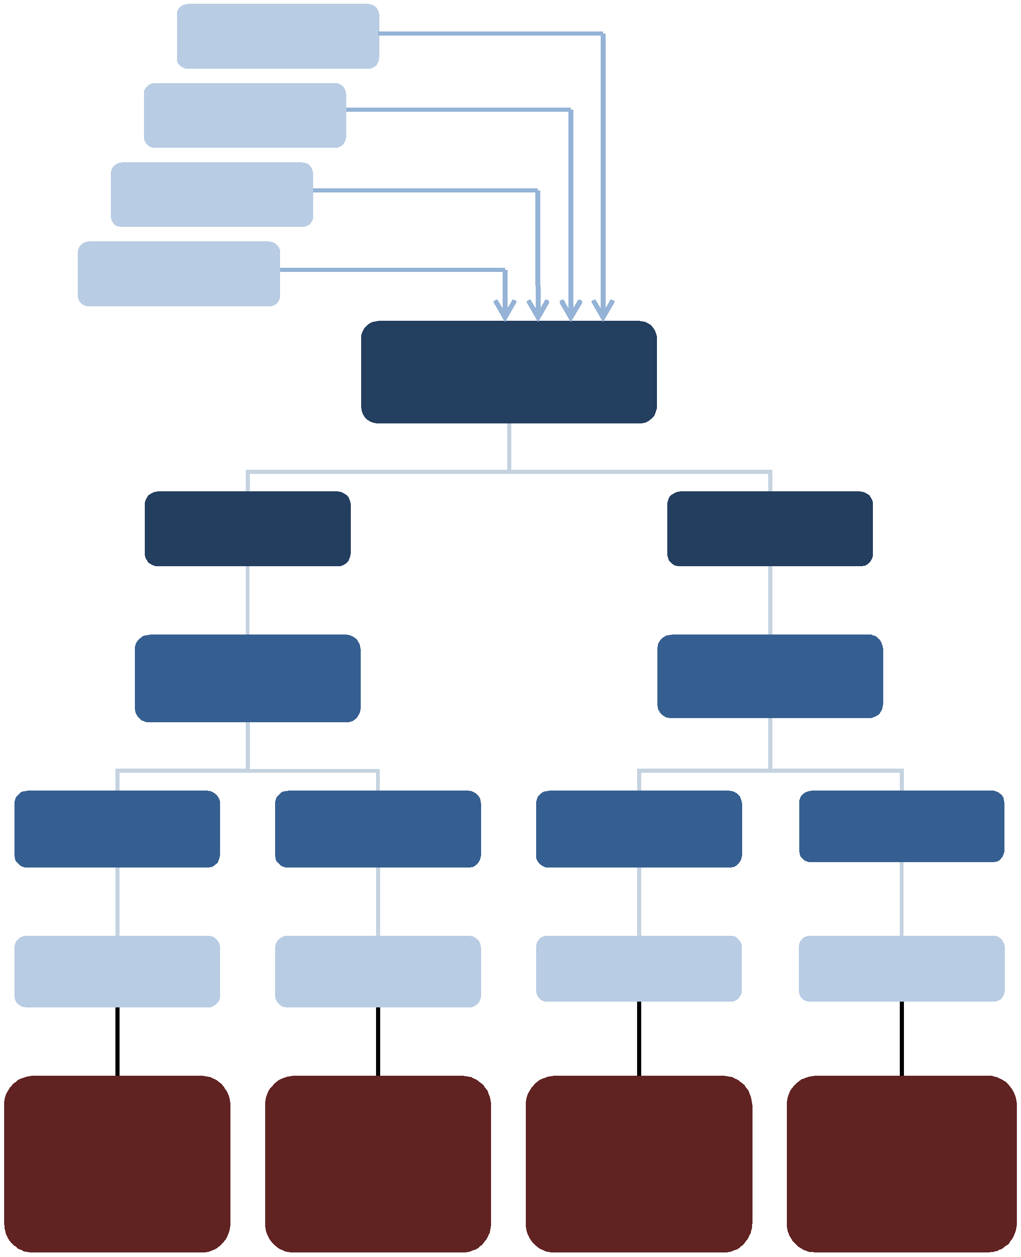

Group B

LIB categorised unsolved and advanced.
Group C

LIB categorised not unsolved and un-advanced.
Group D

LIB categorised not unsolved and advanced.

The outcome of Phases one and two will ultimately leave the Legacy Investigation Branch with a workload that fits within 16 sectors. Figure three provides an outline of the sectors.

Figure 3
 | 1 | 2 | 3 | 4
A | CPOI features, forensic potential identified, LIB categorised unsolved and unadvanced. | CPOI features, no forensic potential identified, LIB categorised unsolved and unadvanced. | CPOI does not feature but forensic potential has been identified. LIB categorised unsolved and unadvanced. | CPOI does not feature and no forensic potential. LIB categorised unsolved and unadvanced.
B | CPOI features, forensic potential identified, LIB categorised unsolved and advanced. | CPOI features, no forensic potential, LIB categorised unsolved and advanced. | CPOI does not feature but forensic potential has been identified. LIB categorised unsolved and advanced. | CPOI does not feature and no forensic potential. LIB categorised unsolved and advanced.
C | CPOI features, forensic potential identified, LIB categorised not unsolved and unadvanced. | CPOI features, no forensic potential, LIB categorised not unsolved and unadvanced. | CPOI does not feature but forensic potential has been identified. LIB categorised not unsolved and unadvanced. | CPOI does not feature and no forensic potential. LIB categorised not unsolved and unadvanced.
D | CPOI features, forensic potential identified, LIB categorised not unsolved and advanced. | CPOI features, no forensic potential, LIB categorised not unsolved and advanced. | CPOI does not feature but forensic potential. LIB categorised not unsolved and advanced. | CPOI does not feature and no forensic potential. LIB categorised not unsolved and advanced.

Final Considerations for Sequencing

Number of CPOIs Featuring in a Case

Once cases have been prepared into final groupings, as detailed above, CPOI cases will be further sequenced according to the number of CPOIs present. This ensures that opportunities to keep the public safe today are maximised.

Age of Case

As highlighted, those offenders who committed crimes in relatively more recent times, may be more likely to present a contemporary risk to public safety than those committed in the 1970s and 1980s.

For this reason, when presented with the final groupings, if any further decision is required regarding which case to sequence, the criteria that will play a key role will be the age of the case. On this basis, the most recently occurring cases in the grouping will be undertaken first.

Operational Impact

Each of these group levels is likely to place a differing degree of demand on tactical operations. Legacy Investigation Branch caseload may therefore, in order to maximise branch efficiency, consist of a blend of cases across review and investigation teams at any one time.

The term ‘Contemporary Persons of Interest’ (CPOI) is defined as any person of interest to the PSNI in connection with any serious crime offence. Serious Crime is defined in the Police Act (1997), Section 93(4) as: Conduct which - Involves the use of violence, results in substantial financial gain or is conducted by a large number of persons in pursuit of a common purpose or - The offence, or one of the offences, is an offence for which a person who has attained the age of 21 and has no previous convictions could reasonably be expected to be sentenced to imprisonment for a term of three years or more.
ACPO Murder Investigation Manual, paragraph 4.3.2
There is a challenge in identifying these cases before conducting a review. The front-loading of the Historical Enquiries Analytical Database creates the potential for this piece of work to be completed. It should be noted that this project involves high volumes of complex data from a range of disparate and often historical sources. While this information offers a good starting point for a broad assessment, the finer details may remain unseen until a review is commenced. An awareness of the limitations will ensure the right level of dependency and any follow-up research can be undertaken in good time.
The Legacy Investigation Branch defines an ‘historical case’ as any case which occurred prior to 01/03/2004 and beginning 01/01/1969.
The term ‘new’ refers to those cases which may be referred by the Service Executive Team to LIB which fall outside of the currently stated remit above.

